
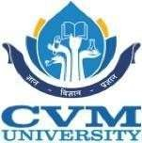
A D PATEL INSTITUTE OF TECHNOLOGY
(The Charutar Vidya Mandal University) GSIRE An ISO 9001:2015 Certified Institute

Topic Name
Hotel Reservation System
A Java report submitted
In partial fulfilment of the requirements for the Degree of Bachelor of Technology
In
Information Technology
Semester – IV
By
Bhavya Nilesh Patel(12402080601018)
Laksh (12402080601070)
Dhruv ka.Patel(12402080601031)

Faculty Guide
Jitiksha Patel
Professor

Academic Year 2025-26 (Even)

Department of Information Technology A D Patel Institute of Technology New Vallabh Vidyanagar
Vitthal Udyognagar - 388121 Anand (Gujarat), India
1. INTRODUCTION
Project Title: Hotel Reservation System
1.1 Objective
The objective of this project is to develop a Hotel Reservation System using Java that allows users to book rooms, cancel reservations, and check room availability.
This project helps in understanding how real-world hotel booking systems work and demonstrates the use of core Java concepts such as Object-Oriented Programming, file handling, and collections.
1.2 Technology Stack
- Programming Language: Java
- Concepts Used:
  - Object-Oriented Programming (OOP)
  - Exception Handling
  - Multithreading
  - Java Collections Framework
  - File Handling
2. PROJECT OVERVIEW
2.1 System Architecture
The system follows a simple architecture:
User → Reservation Manager → Room Classes → File Storage
- The user interacts with the system
- Reservation Manager handles all operations
- Room classes represent different room types
- File storage is used to save booking data
2.2 Features
- Book a room
- Cancel reservation
- Check room availability
- Support for multiple room types
- Waitlist management using Queue
- Data persistence using file handling

2.3 Modules
1. Room Module
Defines different types of rooms using inheritance:
- Single Room
- Double Room
- Suite Room
2. Reservation Module
Stores booking details such as user name and room number.
3. Manager Module
Handles booking, cancellation, and availability checking.
4. File Handling Module
Saves and retrieves reservation data from file.
3. IMPLEMENTATION DETAILS

3. Inheritance and Polymorphism
Inheritance is used to create different room types from a base class Room.
Polymorphism allows different room types to have their own behavior.
3.1 Inner Classes
An inner class Reservation is used inside ReservationManager to store booking details.
3.2 Exception Handling
Exception handling is used to:
- Prevent booking already reserved rooms
- Handle errors gracefully

3.3 Threading
Threading is used to simulate multiple users trying to book rooms at the same time.

3.4 Collection API
- ArrayList is used to store rooms and reservations
- Queue is used to manage waiting list

3.5 File Handling
File handling is used to:
- Save reservation data
- Load data when program starts

4. PROJECT DEMONSTRATION
4.1 Key Functionalities
- Booking a room
- Cancelling a booking
- Viewing available rooms
- Managing waitlist

4.2 Output Screenshots
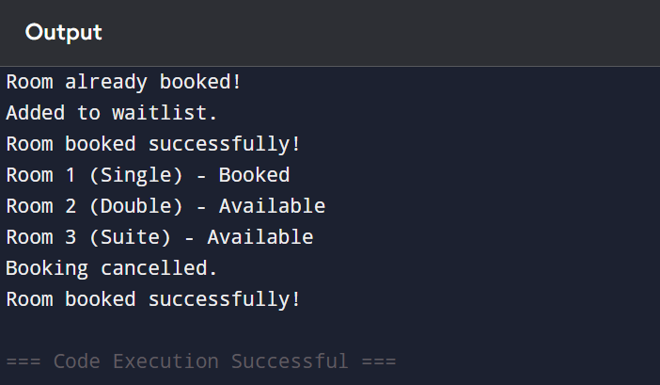

Example output:
- Room booked successfully
- Room already booked → added to waitlist
- Room availability displayed
4.3 User Interface
This project uses a console-based interface where users interact using commands.

5. CHALLENGES AND SOLUTIONS
5.1 Challenges
- Managing multiple booking requests
- Preventing duplicate bookings
- Handling data efficiently

5.2 Solutions
- Used Exception Handling to manage errors
- Used Queue for waitlist management
- Used structured OOP design

6. CONCLUSION
The Hotel Reservation System project successfully demonstrates the use of Java programming concepts in solving real-world problems.
It improves understanding of:
- Object-Oriented Programming
- Data structures
- File handling
7. FUTURE ENHANCEMENTS
- Add graphical user interface (GUI)
- Connect with database (MySQL)
- Add login authentication
- Online booking and payment system

8. REFERENCES
You can paste these (very important for marks):
- Oracle Java Documentation
- https://docs.oracle.com/javase/8/docs/
- GeeksforGeeks (Java Concepts)
- https://www.geeksforgeeks.org/
- W3Schools Java Tutorials
- https://www.w3schools.com/java/
- Java: The Complete Reference by Herbert Schildt
- TutorialsPoint Java Guide

